**Tech spike used for his Assignment:**

JDK :1.8,Spring boot:2.5.2,Spring Security, Spring framework.

DB: h2database (in memory DB)

Server :tomcat

**Test the services in postman:**

**Service 1**:This is initial service to get Authentication token , it can used to test the business services.

**Repeated Step** : To test all the services:

*Authentication token what we received as part service 1 , we should pass as Access Token in Authorization section by selecting type as OAuth2.0*

**2.To Add recipe:**

Pass same access token received on service 1 as part of Authorization and add body as below

**3.Fetch all Recipes (without any filters)**

**4.Update Recipe:**

Pass same access token received on service 1 as part of Authorization and add body as below.

**5.Fetch all Recipes (applying filters)**

Pass same access token received on service 1 as part of Authorization and add body as below

Don’t have any items with above criteria.

Try with different criteria

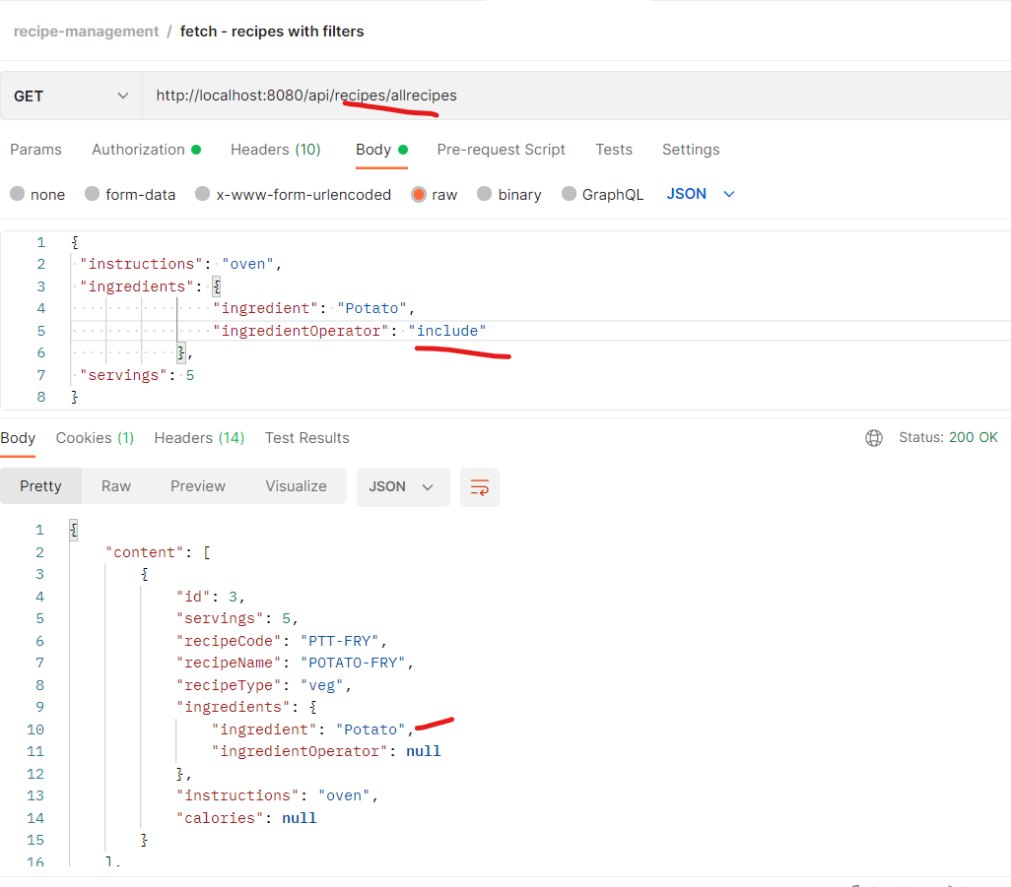

**6.Delete Recipe:**

Pass same access token received on service 1 as part of Authorization and add body as below

First fetch all the recipes

Now delete ID :2

Fetch the recipes again and ID 2 is not available:

